Accessing reports through School Talk

STEP 1 : Log into School Talk using the email you have provided to the school on enrolment (or have notified the school of a change)
STEP 2:
Click on reports on the right hand side of the menu
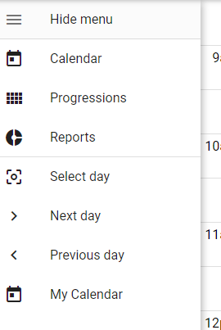

STEP 3:The report that opens up will be the most current. You will see the date and also be able to print the document. You can also download this report by clicking the printer option

